Supporting Information

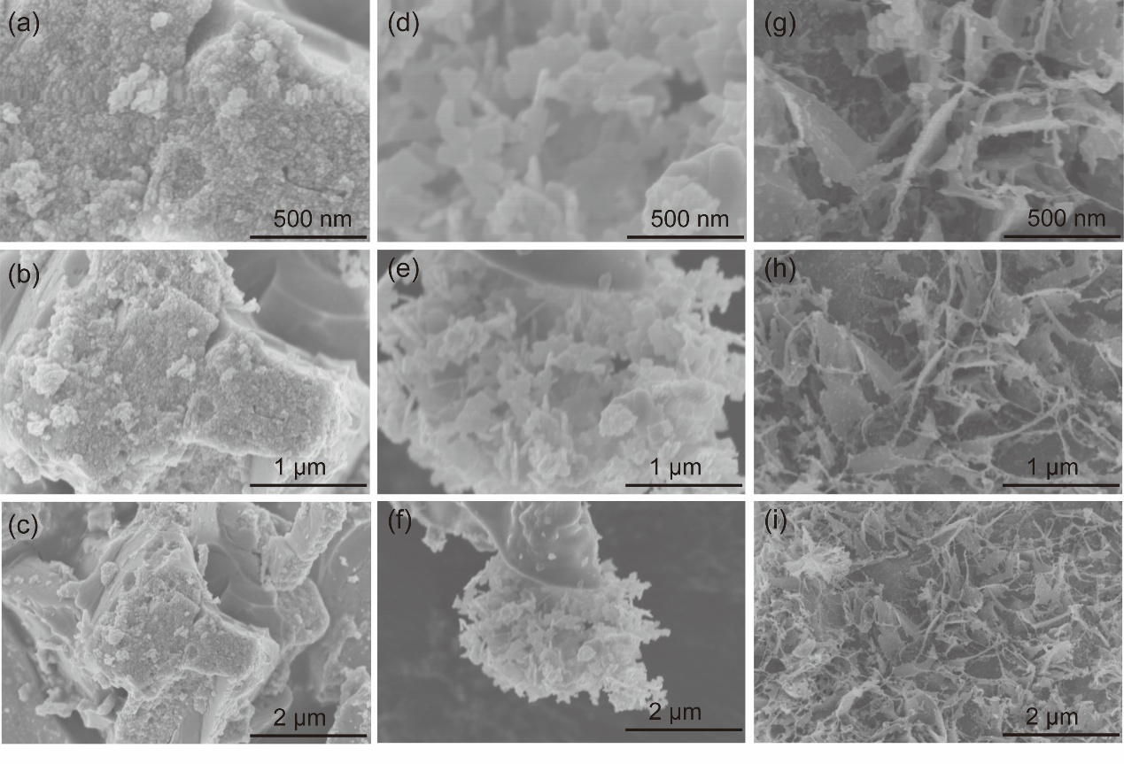
Figure S1. The SEM spectra of (a-c) Mo₂C, (d-f) Mo₂C-MoC/NC-0.1, (g-i) Mo₂C-MoC/NC-0.5.

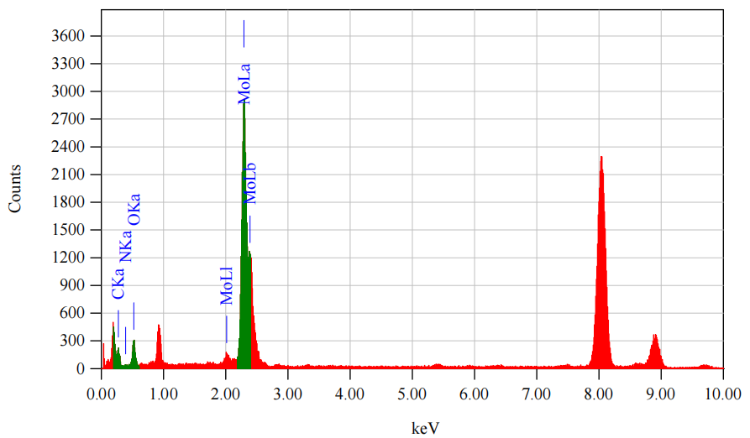
Figure S2. The corresponding elemental maps of C, N, O, and Mo of the Mo₂C-MoC/NC-0.3 catalyst sample.

Table S1. The corresponding elemental table of C, N, O and Mo in the Mo₂C-MoC/NC-0.3 catalyst sample.
Element (keV) | Mass% | Atom% | Sigma
C K  N K  O K  Mo L (Ref.) | 0.42  0.21  2.14  97.24 | 2.92  1.23  11.17  84.68 | 0.04  0.03  0.08  0.86

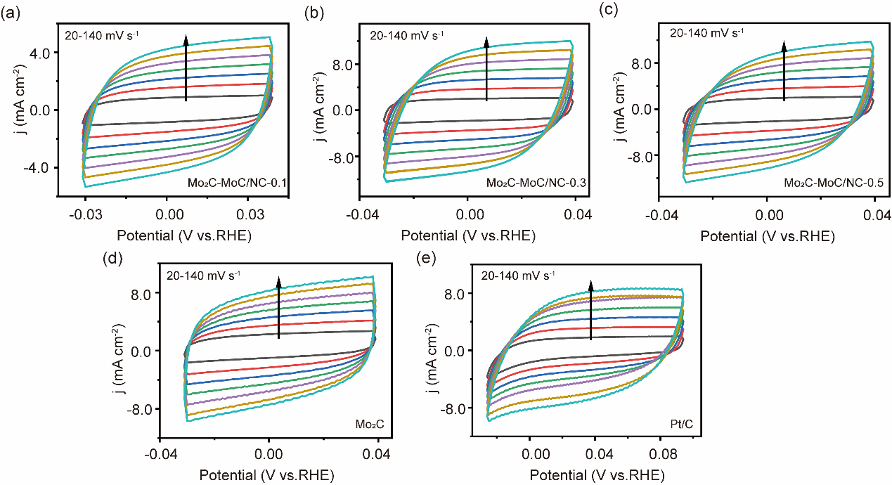
Figure S3. The CV of (a) Mo₂C-MoC/NC-0.1, (b) Mo₂C-MoC/NC-0.3, (c) Mo₂C-MoC/NC-0.5, (d) Mo₂C, (e) 20% Pt/C, with the scan rates of 20, 40, 60, 80, 100, 120 and 140 mV·s⁻¹ in 1.0 M KOH.

Figure S4. (a) ECSA values of various catalysts, (b) ECSA-normalized LSV curves of different catalysts for HER.

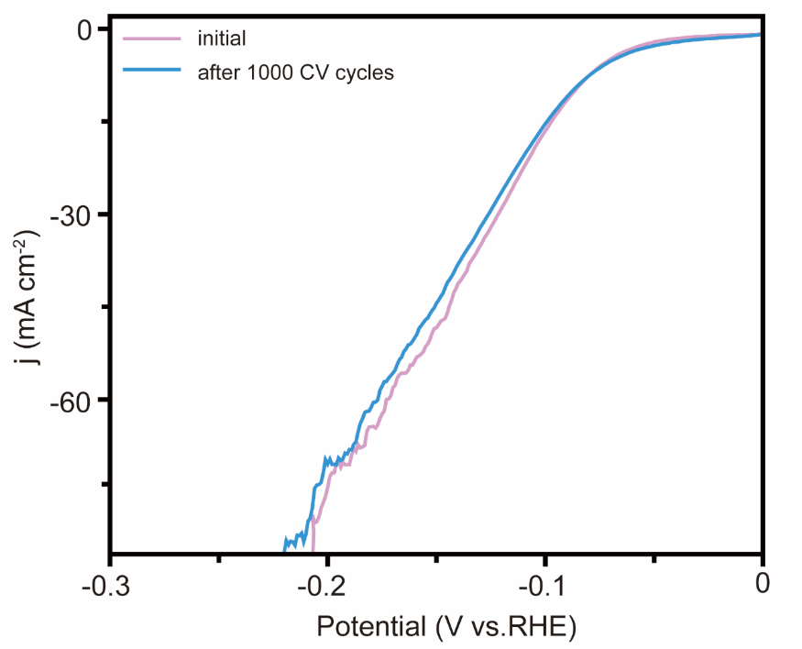
Figure S5. The LSV curves before and after 1000 cycles of CV test in 1.0 M KOH.

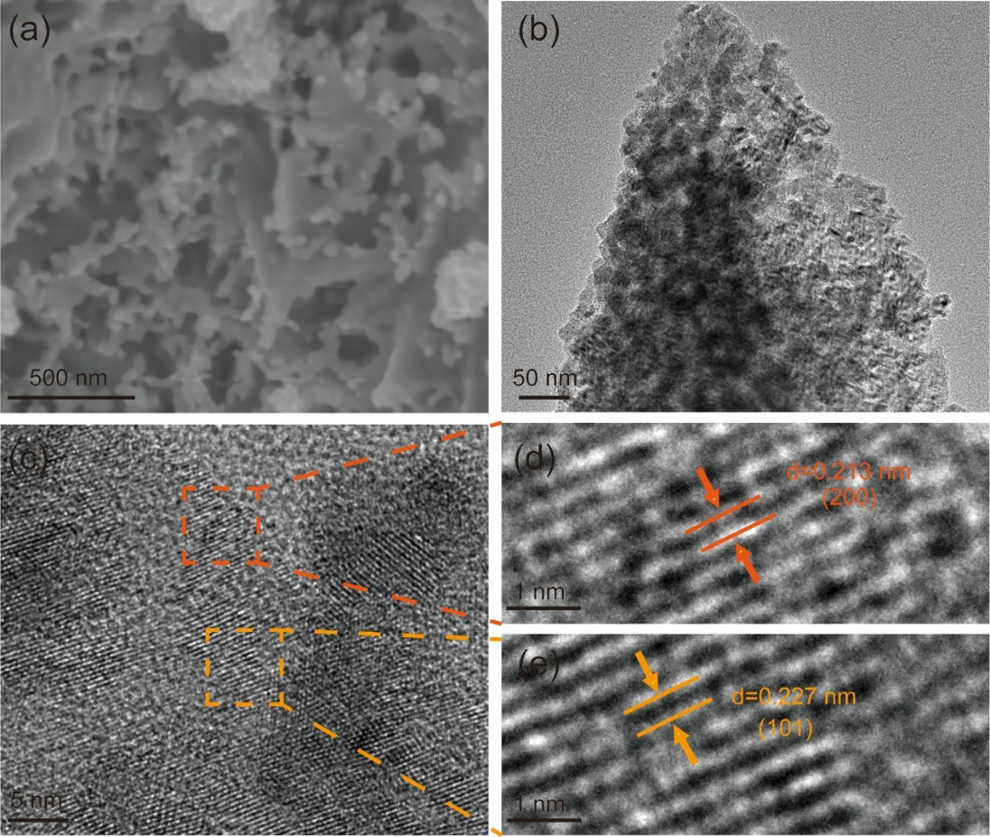
Figure S6. (a) SEM, (b,) TEM, (c-e) HRTEM of Mo₂C-MoC/NC-0.3 after long-term cycling experiments.

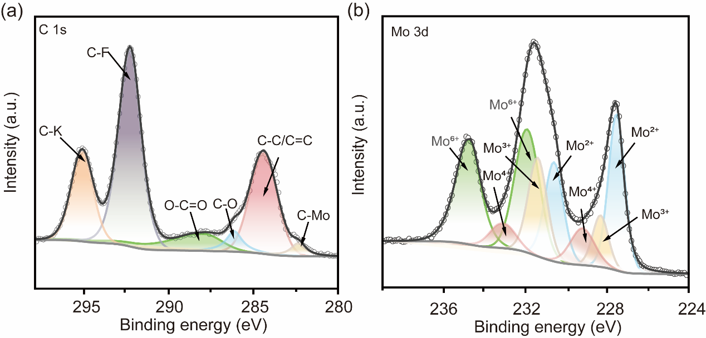
Figure S7. The XPS spectra of Mo₂C-MoC/NC-0.3 after long-term cycling experiments (a) The XPS spectra of C 1s in Mo₂C-MoC/NC-0.3. The test results indicate that the sample still contains elements such as Mo, C, and O. In addition, there are also small amounts of elements with F and K. The C-F and C-K bonds in the figure confirm their existence, which may be due to the attachment of K⁺ ions in the alkaline electrolyte, and the experiment used Nafion solution containing F elements, resulting in the retention of some elements. (b) The XPS spectra of Mo 3d in Mo₂C-MoC/NC-0.3.

Table S2. Comparison of η₁₀ for Mo₂C-MoC/NC-0.3 with the recently reported Mo₂C-based HER electrocatalysts.
Sample | η₁₀ (mV) | Tafel (mV dec⁻¹) | Reference
Mo₂CeMoC/NF-650 | 28.6 | 73 | [1]
ZNDM-MoC/Mo₂C | 69 | 57.9 | [2]
Fe-Mo₂C @ NCF | 76 | 65 | [3]
Mo₂C/Mo₃N₂/C | 76 | 52.6 | [4]
Mo₂C/MoC/MoP@NC-650-0 | 78 | 52 | [5]
Co/MoC@NC | 80.6 | 128 | [6]
Mo₂C/MoC/CNT | 82 | 42 | [7]
NiCo-MoxC | 86.6 | 62.8 | [8]
Mo₂C-MoC/NC-0.3 | 87 | 54.8 | this work
MoO₂/MoC | 104 | 60.0 | [9]
B-Mo/Mo₂C | 108 | 52.7 | [10]
Mg-Mo₂C | 111 | 68.23 | [11]
Mo₂C/MoC-1 | 119 | 49.8 | [12]
Zn-MoC/Mo₂C | 139 | 50 | [13]
Mo₂C-MoC/C | 139.4 | 55 | [14]
P-Ni-Mo₂C-2h | 140.5 | 50.7 | [15]
Ni_{0.5}@MoC_{x}/NC | 150 | 74.6 | [16]
W-Mo_{x}C/C | 178 | 54.3 | [17]
β-Mo₂C/α-MoC_{1-x} | 242 | 78 | [18]
Co-Mo_{x}N/Mo₂C | 297 | 120.7 | [19]

