Supplementary information for
In-situ Surface Vanadate Anchoring Strategy for Robust and Efficient Seawater Oxidation

Jooheon Sun¹, Jiseok Kwon¹, Seunggun Choi¹, Yeseung Lee¹, Ungyu Paik¹* and Taeseup Song¹*

¹Department of Energy Engineering, 222 Wangsimni-ro, Seongdong-gu, Hanyang University, Seoul 04763, Korea
*Corresponding authors (U Paik, T Song) E-mail: upaik@hanyang.ac.kr, tssong@hanyang.ac.kr

Experimental
Materials and Instrumentation
All chemicals were used as purchased without further treatment: water (deionized water, DIW, Samchun), nickel(II) nitrate hexahydrate (Ni(NO₃)₂·6H₂O, Sigma Aldrich, 98%), Ni foam (MTI Korea), Sodium orthovanadate (Na₃VO_{4,} Sigma Aldrich, 90%), Potassium hydroxide (KOH, Sigma Aldrich, 93%), and Hexamethylenetetramine(C₆H₁₂N₄, Sigma Aldrich, 99%) . X-ray diffraction patterns (XRD) were collected using a Rigaku SmartLab instrument equipped with a Cu Kα X-ray source. Transmission electron microscopy (TEM) and high-resolution TEM (HR-TEM) were performed using a JEM 2100F (JEOL) and NEO ARM (JEOL) instrument. Field-emission scanning electron microscopy (FE-SEM) was performed using a field-emission scanning electron microanalyzer (JEOL JSM07600F). The XPS analysis was conducted using a VG Microtech ESCA2000 instrument with monochromated Al K_{α} radiation as the excitation source.

Synthesis of the electrocatalysts
2.86 g of nickel(II) nitrate hexahydrate (Ni(NO₃)₂·6H₂O) and 2.86 g of hexamethylenetetramine were dissolved in 55 mL of deionized water and stirred for 30 minutes. The Nickel foam (NF) was then immersed in the prepared solution and placed in a Teflon-lined autoclave, followed by hydrothermal treatment at 140 °C for 3 hours. After naturally cooling to room temperature, the resulting Ni(OH)₂-coated NF was rinsed with deionized water and dried in air. The vanadate anchoring is carried out by electrochemical activation. A series of Ni(OH)₂-xVi samples were prepared via applying CV activation of Ni(OH)₂ in 1 M KOH medium containing different concentrations of VO₄³⁻ oxyanions (0.25, 0.5, and 0.75 M ) at 100 mV s⁻¹ from 1 to 1.8 V_{RHE} for 30 cycles without iR compensation.

Electrochemical Measurements
Electrochemical measurements were performed using a PGSTAT302N Potentiostat/Galvanostat in a conventional three-electrode configuration, employing a platinum sheet as the counter electrode and an Ag/AgCl electrode as the reference. Linear sweep voltammetry (LSV) was conducted at a scan rate of 5 mV s⁻¹, and all data were corrected for iR drop. Series resistance values were obtained via electrochemical impedance spectroscopy (EIS). The electrochemical active surface area (ECSA) was estimated from the double-layer capacitance (C_{dl}), which was determined by measuring the capacitive current in the non-faradaic region. As this current arises from double-layer charging, it is linearly proportional to the ECSA. Assuming a specific capacitance (C_{s}) of 40 μF cm⁻², the ECSA was calculated using the following expression:
$$ECSA=\frac{ C_{dl} (mF{ cm}^{-2})}{ 0.04 (mF{ cm}^{-2})} x S ({cm}^{2}) \left(1\right)$$
where S is the geometric surface area of electrode (in this case, 0.196 cm²). Turnover frequency (TOF) for OER is investigated via the following equation.
$$Tunrover frequency (TOF)=\frac{ j×A }{n×F×N_{s} } (2)$$
where j is a current density, A is the geometric area of the electrode, n is the number of electrons transferred to evolve a molecule of the product (for O₂, n is 4), F is Faradaic constant and N_{s} is the concentration of active site per unit area. N_{s} value estimated by variation of current density at oxidation (Ni^{2+/}Ni³⁺) peak of nickel depending on scan rate.

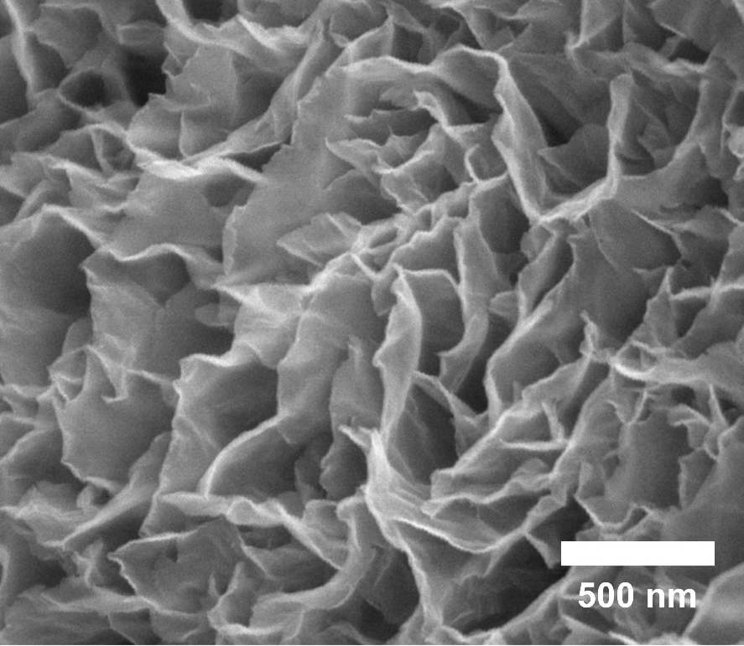
Fig. S1 Scanning electron microscopy (SEM) images of Ni(OH)₂.

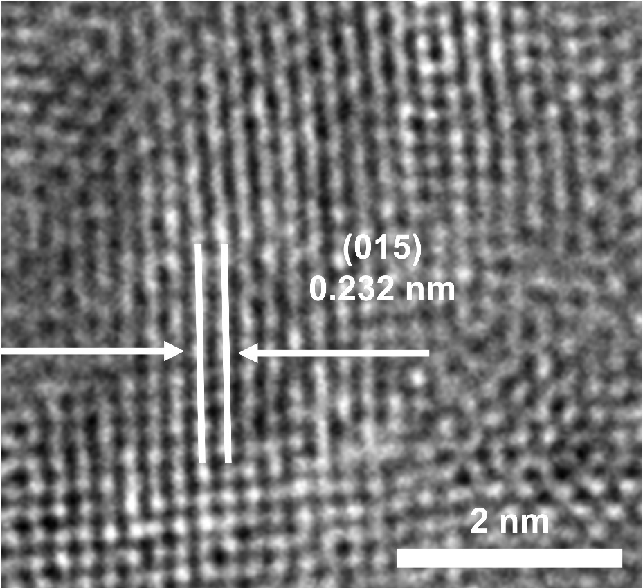
Fig. S2 High-resolution transmission electron microscope (TEM) images of Ni(OH)₂.

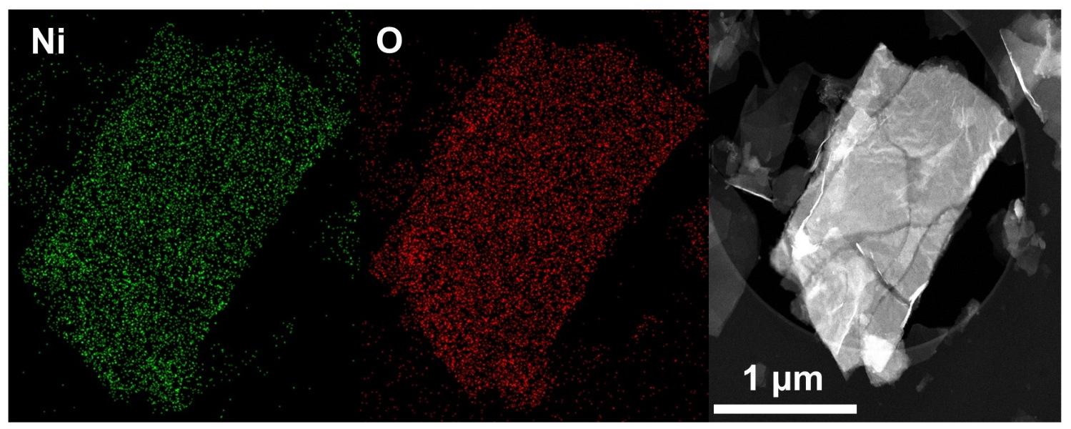
Fig. S3 Energy dispersive X-ray spectroscopy (EDS) elemental mapping of Ni(OH)₂.

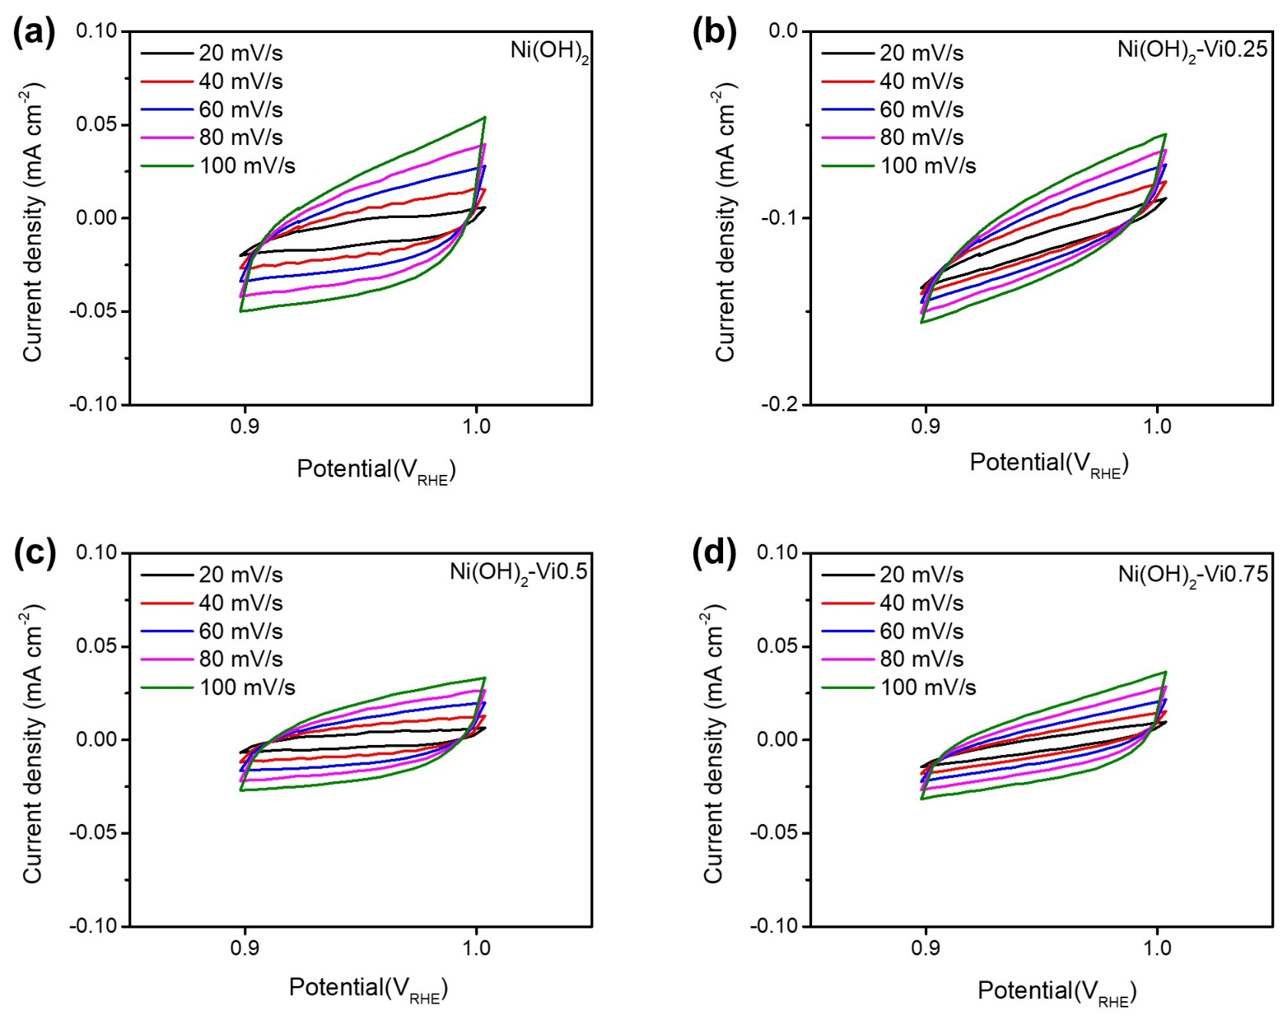
Fig. S4 Cycle voltammetry (CV) measured at a voltage range from 0.90 to 1.00 V_{RHE} with different scan rates, respectively, 20, 40, 60, 80 and 100 mV s⁻¹ for (a) Ni(OH)₂, (b) Ni(OH)₂-Vi0.25, (c) Ni(OH)₂-Vi0.5 and (d) Ni(OH)₂-Vi0.75

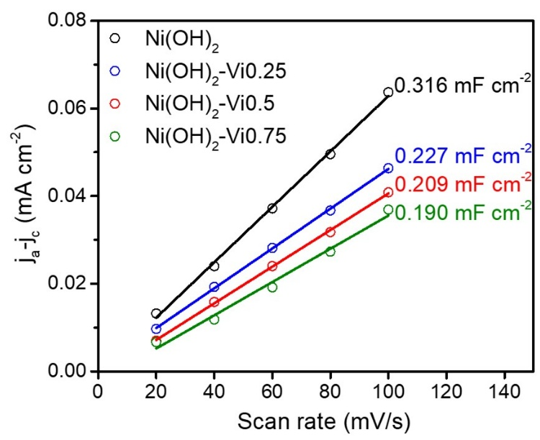
Fig. S5 Current difference between anodic and cathodic current density depending on scan rate. Fitted line was used to calculate electrochemical surface area (ECSA).
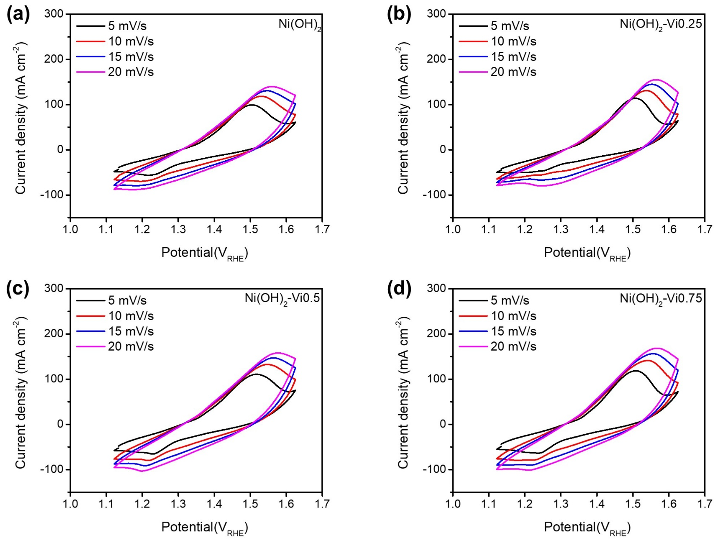
Fig. S6 Cyclic voltammetry at different scan rates of 5, 10, 15 and 20 mV s⁻¹, respectively. (a) Ni(OH)₂, (b) Ni(OH)₂-Vi0.25, (c) Ni(OH)₂-Vi0.5 and (d) Ni(OH)₂-Vi0.75

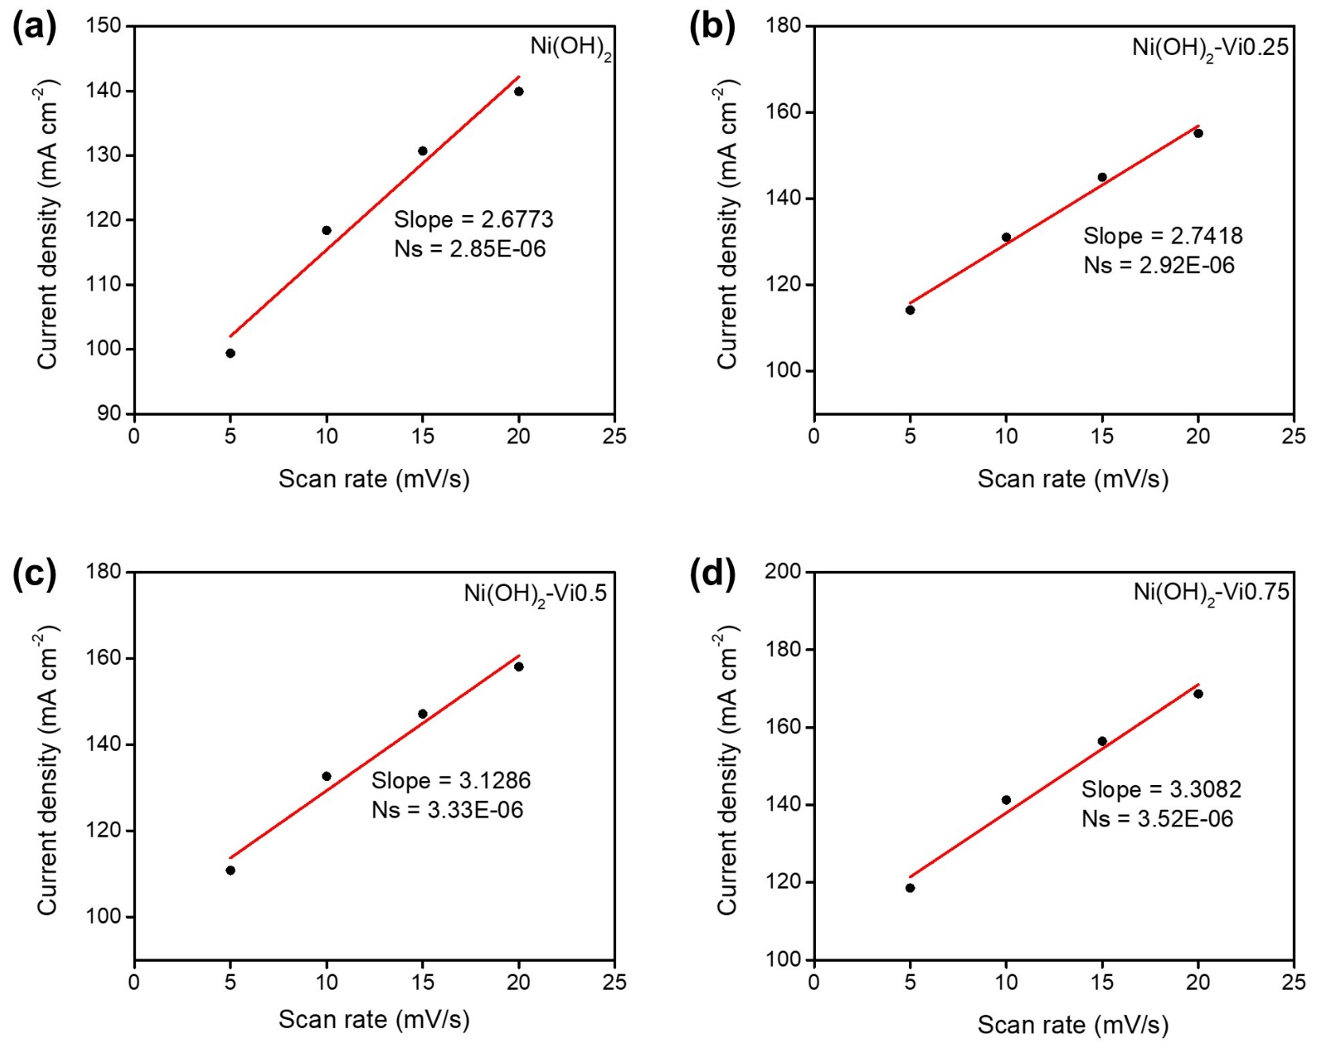
Fig. S7 Linear relationship of the oxidation peaks current as a function of scan rate in Fig. S6 for estimating the number of redox active sites.

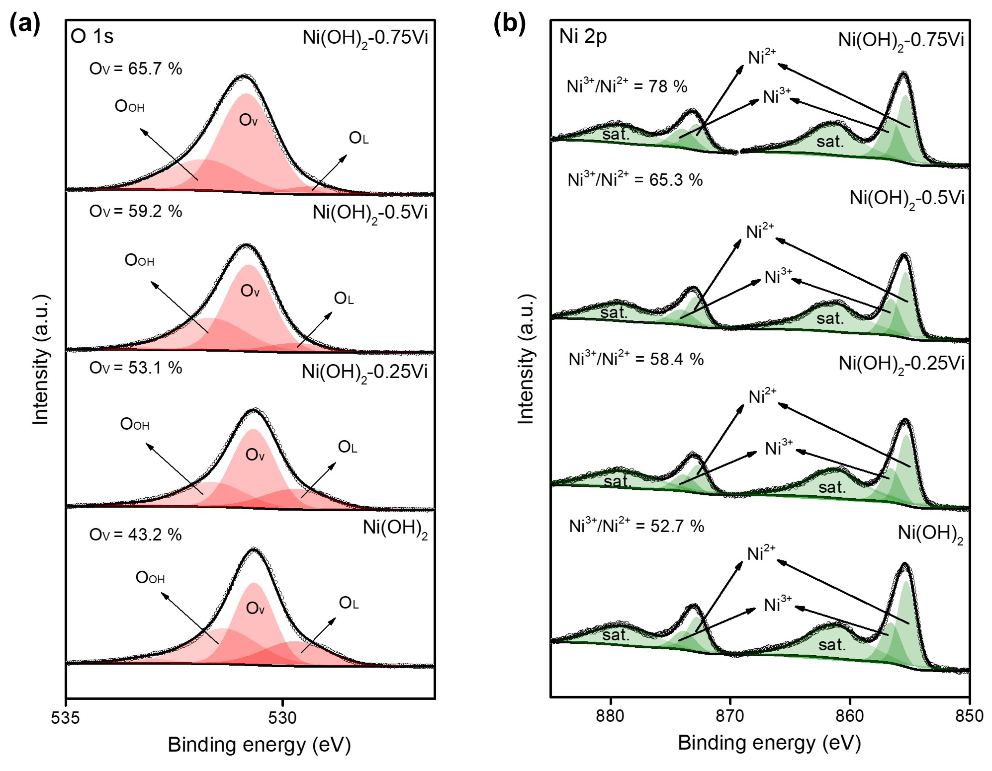
Fig. S8 (a) O 1s XPS spectra of Ni(OH)₂-xVi. (b) Ni 2p XPS spectra of Ni(OH)₂-xVi.

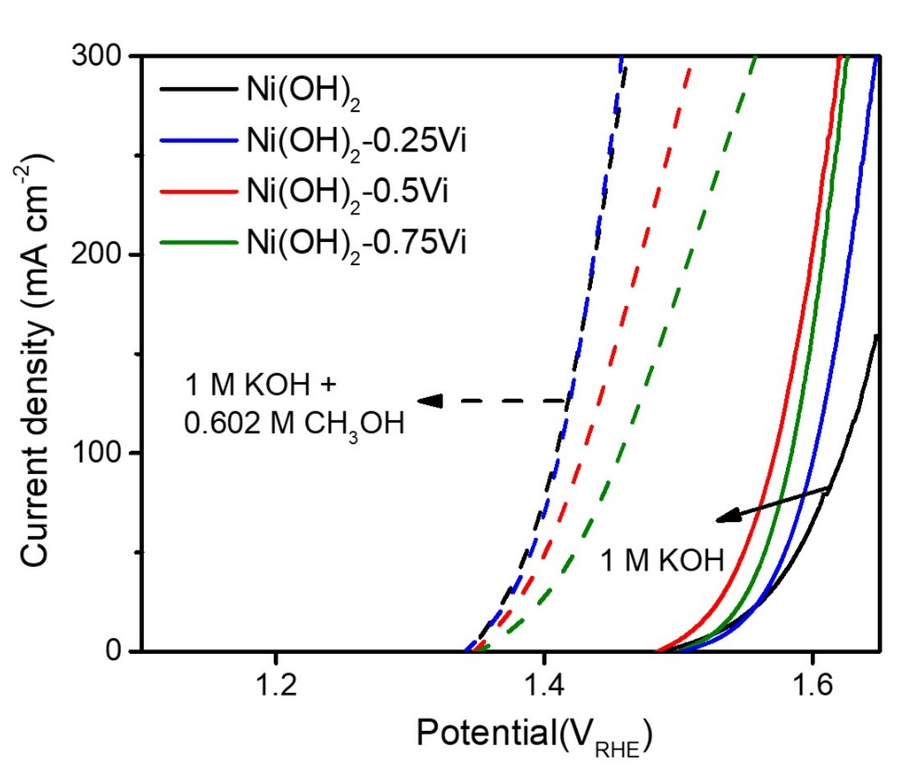
Fig. S9 Polarization curves measured with 1 M KOH and 1 M KOH + 0.602 M CH₃OH.

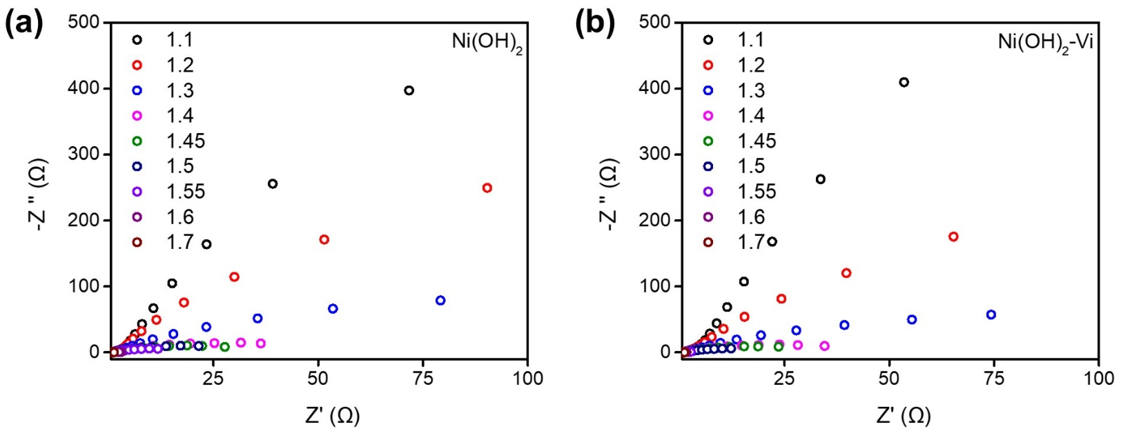
Fig. S10 Operando Nyquist plots at various potential from 1.1 to 1.7 V_{RHE} for (a) Ni(OH)₂, (b) Ni(OH)₂-Vi.

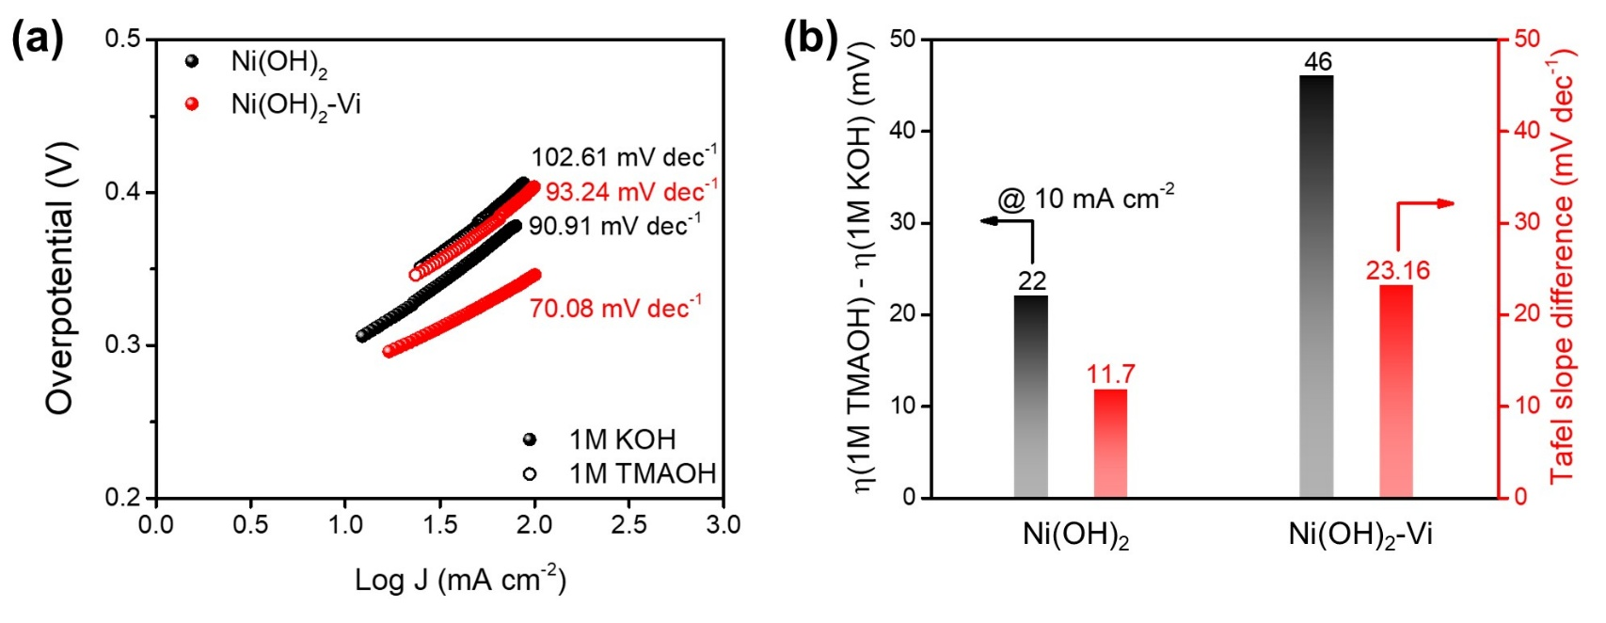
Fig. S11 (a) Tafel slope under 1 M KOH and 1 M TMAOH (b) Activity variation of overpotential and Tafel slope under 1 M KOH and 1 M TMAOH.

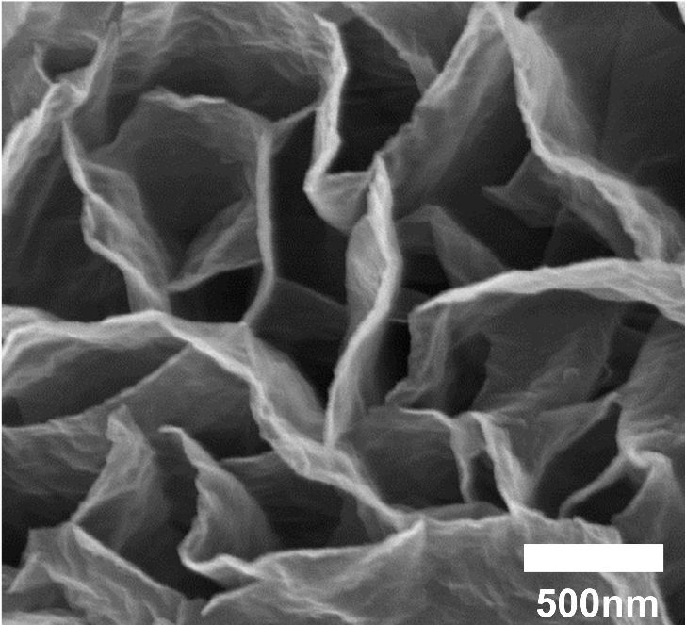
Fig. S12 Scanning electron microscopy (SEM) images of Ni(OH)₂-Pi.
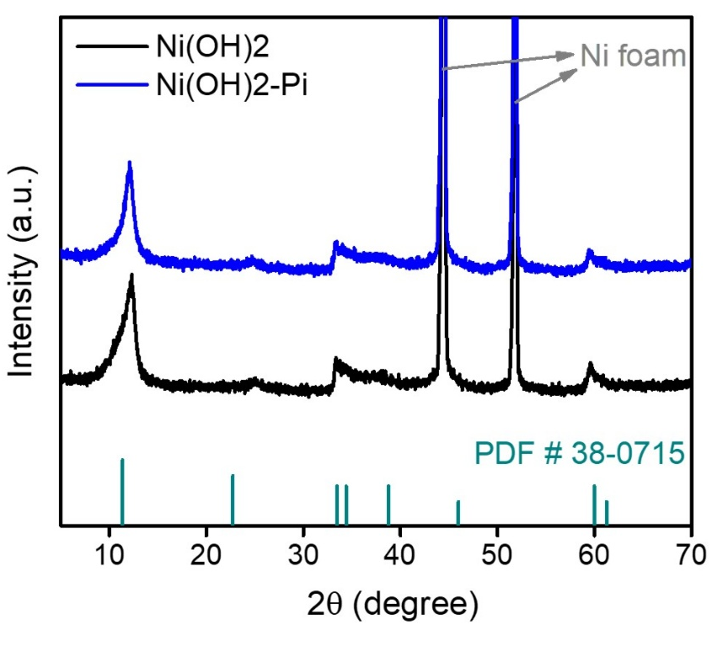
Fig. S13 X-ray diffraction (XRD) patterns of Ni(OH)₂ and Ni(OH)₂-Pi.

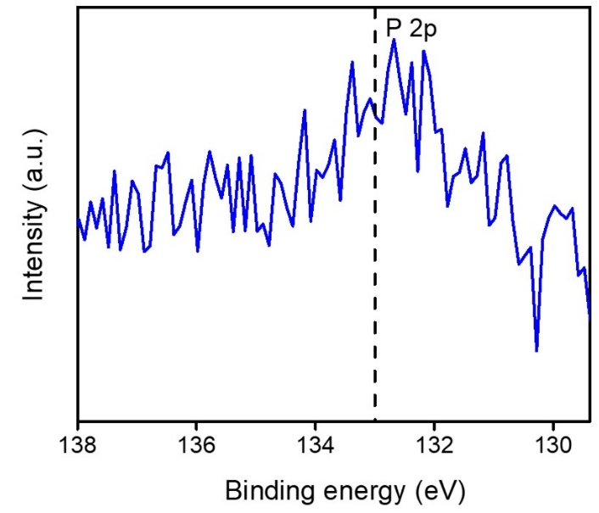
Fig. S14 XPS spectra of P 2p for Ni(OH)₂-Pi.

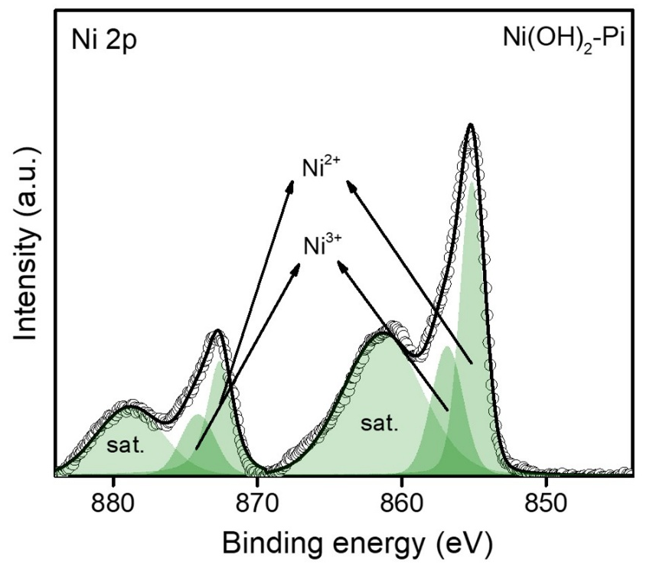
Fig. S15 XPS spectra of Ni 2p for Ni(OH)₂-Pi.

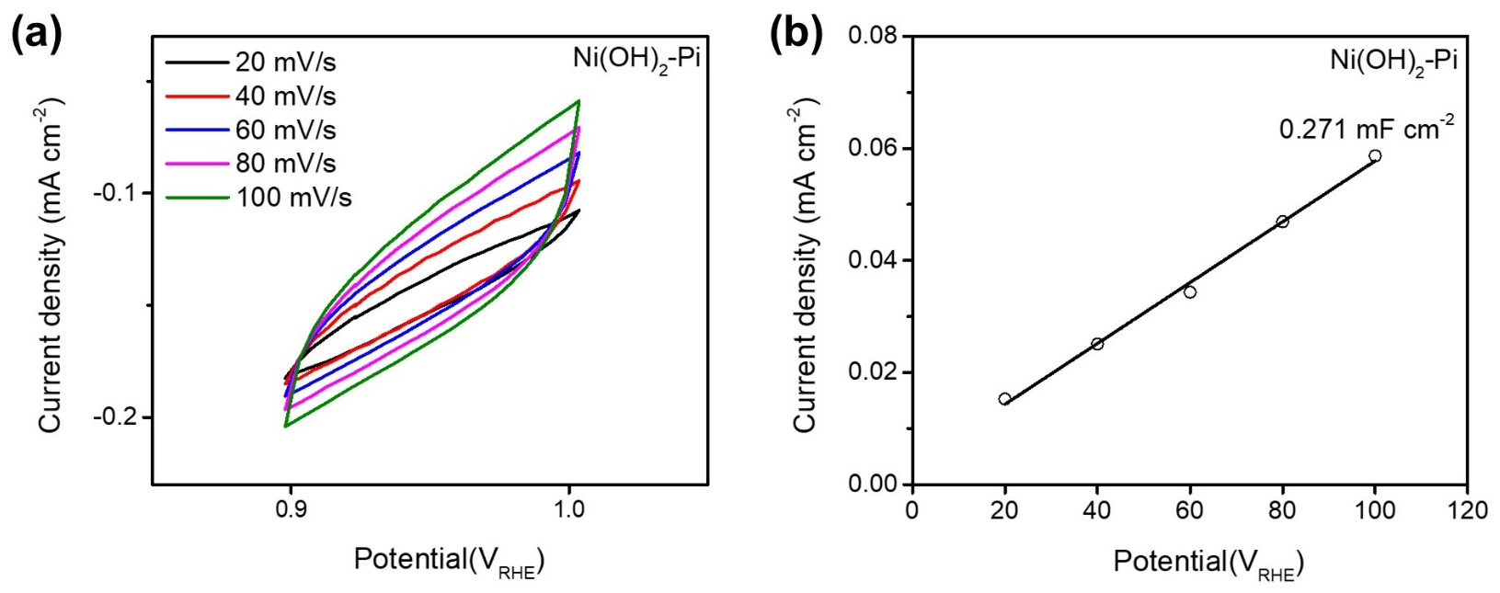
Fig. S16 (a) Cycle voltammetry (CV) measured at a voltage range from 0.90 to 1.00 V_{RHE} with different scan rates, respectively, 20, 40, 60, 80 and 100 mV s⁻¹ for Ni(OH)₂-Pi. (b) Current difference between anodic and cathodic current density depending on scan rate for Ni(OH)₂-Pi.

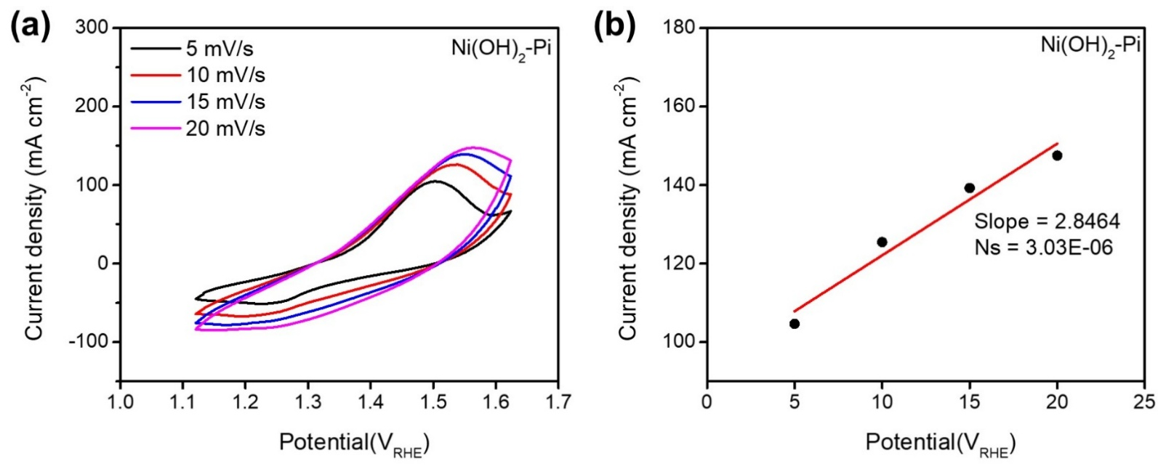
Fig. S17 (a) Cyclic voltammetry at different scan rates of 5, 10, 15 and 20 mV s⁻¹ for Ni(OH)₂-Pi. (b) Linear relationship of the oxidation peaks current as a function of scan rate for Ni(OH)₂-Pi.
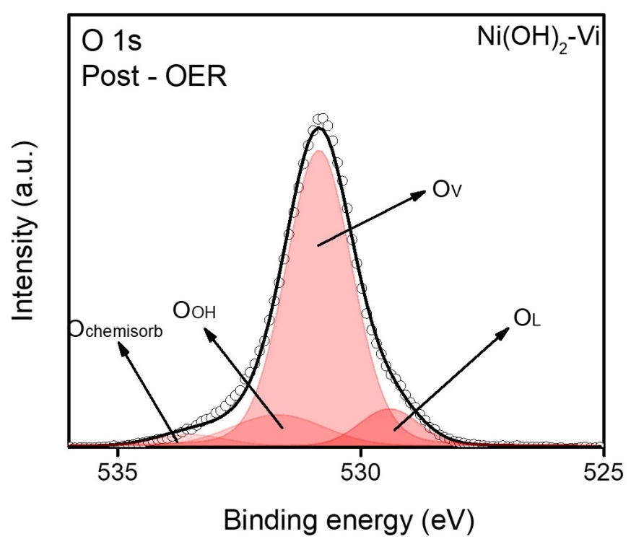
Fig. S18 Post-OER O 1s X-ray photoelectron spectroscopy (XPS) spectra of Ni(OH)₂-Vi.

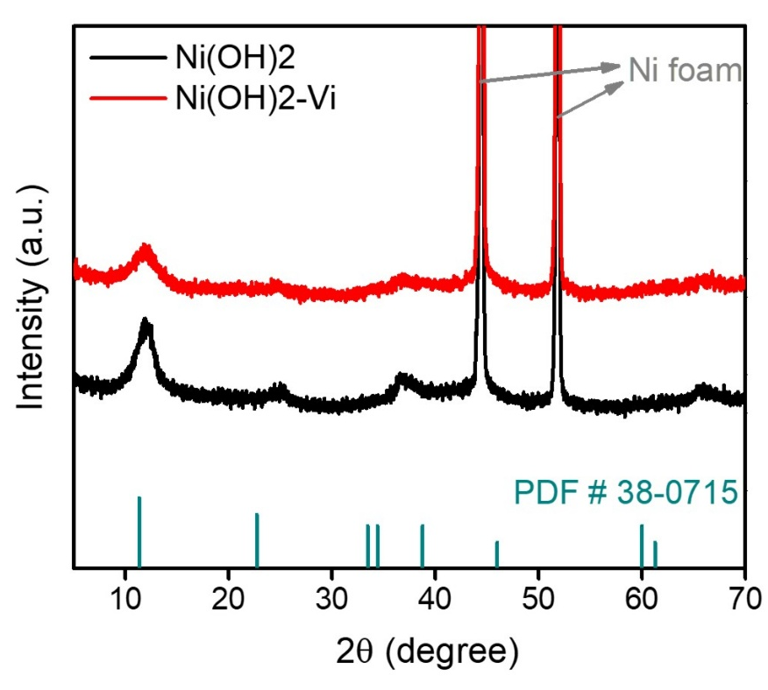
Fig. S19 Post OER X-ray diffraction (XRD) patterns of Ni(OH)₂-Pi.

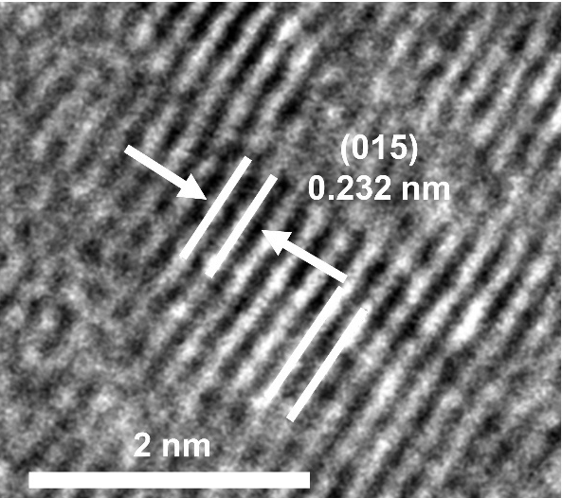
Fig. S20 Post-OER high-resolution transmission electron microscopy (HR-TEM) image of Ni(OH)₂-Pi.

Table S1. Electrochemical surface area (ECSA) value of Ni(OH)₂-xVi.
Sample | ECSA
Ni(OH)₂ | 7.9
Ni(OH)₂-Vi0.25 | 5.675
Ni(OH)₂-Vi0.5 | 5.225
Ni(OH)₂-Vi0.75 | 4.75

Table S2. Charge transfer resistance (R_{ct}) of Ni(OH)₂-xVi.
Sample | R_{ct} (Ω)
Ni(OH)₂ | 2.85
Ni(OH)₂-Vi0.25 | 2.64
Ni(OH)₂-Vi0.5 | 2.00
Ni(OH)₂-Vi0.75 | 3.52

Table S3. Atomic ratio of Ni to V of Ni(OH)₂-xVi based on XPS analysis.
Sample | Ni / V atomic ratio
Ni(OH)₂ | -
Ni(OH)₂-Vi0.25 | 33.1
Ni(OH)₂-Vi0.5 | 21.4
Ni(OH)₂-Vi0.75 | 18.3

